**Bug Report**

**Bug Report 1: User Login Issue**

**Bug ID:** BUG-001 **Date Reported:** June 25, 2025 **Reporter:** DUMNE VIJAY

**Environment**

* **Application**: https://www.saucedemo.com/
* **Version**: V1
* **Browser**: Chrome Version 137.0.7151.120 (Official Build) (64-bit)
* **OS**: Windows 11
* **Test Environment**: Prod

**Bug Summary**

Users with valid login credentials are unable to successfully authenticate and access the system, receiving a "user has been locked out" error message despite having correct username and password.

**Severity: High** - Critical functionality impaired, users cannot access the system

**Priority: P1** - Immediate attention required

**Bug Type:** Functional Defect

**Steps to Reproduce**

1. Navigate to the login page
2. Enter valid username: locked_out_user
3. Enter correct password: secret_sauce
4. Click the "Login" button
5. Observe the error message

**Expected Result**

* User should be successfully authenticated
* User should be redirected to the main application/dashboard
* No error messages should appear for valid credentials

**Actual Result**

* Red error banner displays: "Epic sadface: Sorry, this user has been locked out."
* User remains on the login page
* Authentication fails despite correct credentials
* Login button remains active but non-functional for this user

**Additional Information**

**Test Data Used**

* **Username**: locked_out_user
* **Password**: secret_sauce
* **Status**: According to accepted usernames list, this should be a valid user

**Screenshots**

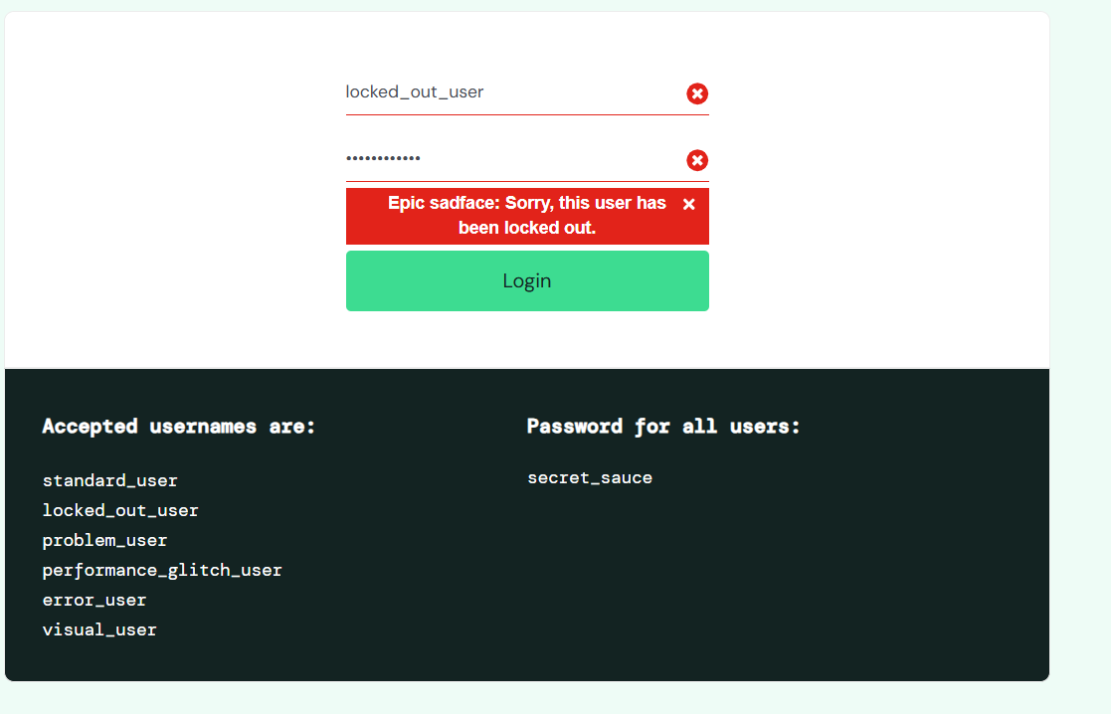

**Root Cause Analysis (Initial Assessment)**

* Possible account lockout mechanism triggered incorrectly
* Authentication service may not be properly validating credentials
* User account status not being checked correctly
* Potential database/backend connectivity issues

**Impact Assessment**

* **User Impact**: High - Prevents legitimate users from accessing the system
* **Business Impact**: High - Affects user productivity and system availability
* **Frequency**: Unknown - needs investigation across all user accounts

**Suggested Fix Priority**

Immediate - This blocks basic system functionality

**Test Cases to Verify Fix** [**TC_001**]

1. Verify locked_out_user can login with correct credentials
2. Test all other accepted usernames with correct password
3. Verify error handling for invalid credentials still works
4. Test account lockout mechanism works as intended for actual security violations
5. Verify no false positive lockouts occur

**Additional Notes**

* This appears to be related to authentication logic rather than UI issues
* May need to check backend logs for authentication attempts
* Consider reviewing account lockout policies and implementation
* Test in different browsers to rule out client-side issues

**Status**: Open  
**Assigned To**: [Developer/Team Name]  
**Next Action**: Investigation and root cause analysis required

**Bug Report 2: Product Navigation Redirection Issue**

**Bug ID:** BUG-002 **Date Reported:** June 25, 2025 **Reporter:** DUMNE VIJAY

**Environment**

* **Application**: https://www.saucedemo.com/
* **Version**: V1
* **Browser**: Chrome Version 137.0.7151.120 (Official Build) (64-bit)
* **OS**: Windows 11
* **Test Environment**: Prod

**Bug Summary** When logged in as problem_user, clicking on "Sauce Labs Backpack" product name redirects to wrong product page (Fleece Jacket) instead of the correct backpack product page.

**Severity: Medium** - Functional issue affecting user experience but not blocking core functionality **Priority: P2** - Should be fixed in next release **Bug Type:** Functional Defect

**Steps to Reproduce**

1. Navigate to login page
2. Login with username: problem_user, password: secret_sauce
3. Browse products on homepage
4. Click on "Sauce Labs Backpack" product name/link
5. Observe the product details page that opens

**Expected Result**

* Clicking on "Sauce Labs Backpack" should redirect to backpack product details page
* Page should display backpack image, description, and correct product information
* URL should reflect the backpack product

**Actual Result**

* Clicking on "Sauce Labs Backpack" redirects to "Sauce Labs Fleece Jacket" product page
* Wrong product details are displayed (jacket instead of backpack)
* User sees incorrect product information and cannot access intended backpack details

**Additional Information** **Test Data Used**

* **Username**: problem_user
* **Password**: secret_sauce
* **Product**: Sauce Labs Backpack → redirects to Sauce Labs Fleece Jacket

**Screenshots**

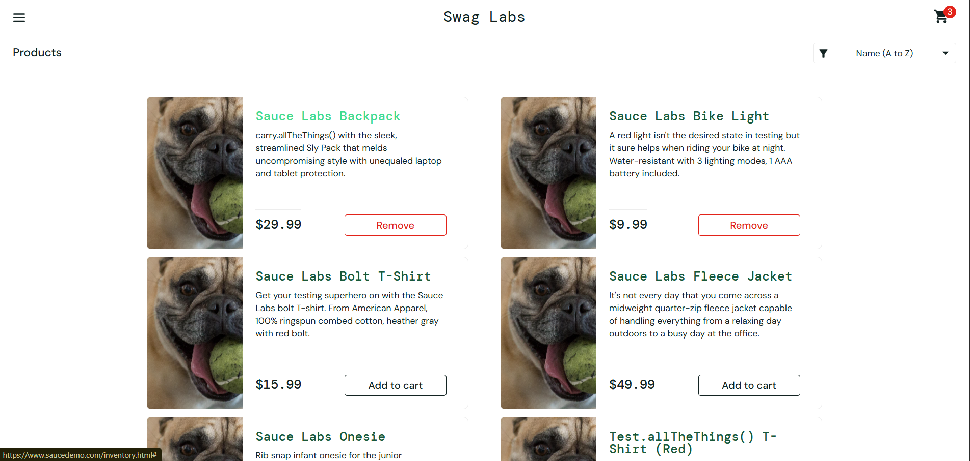

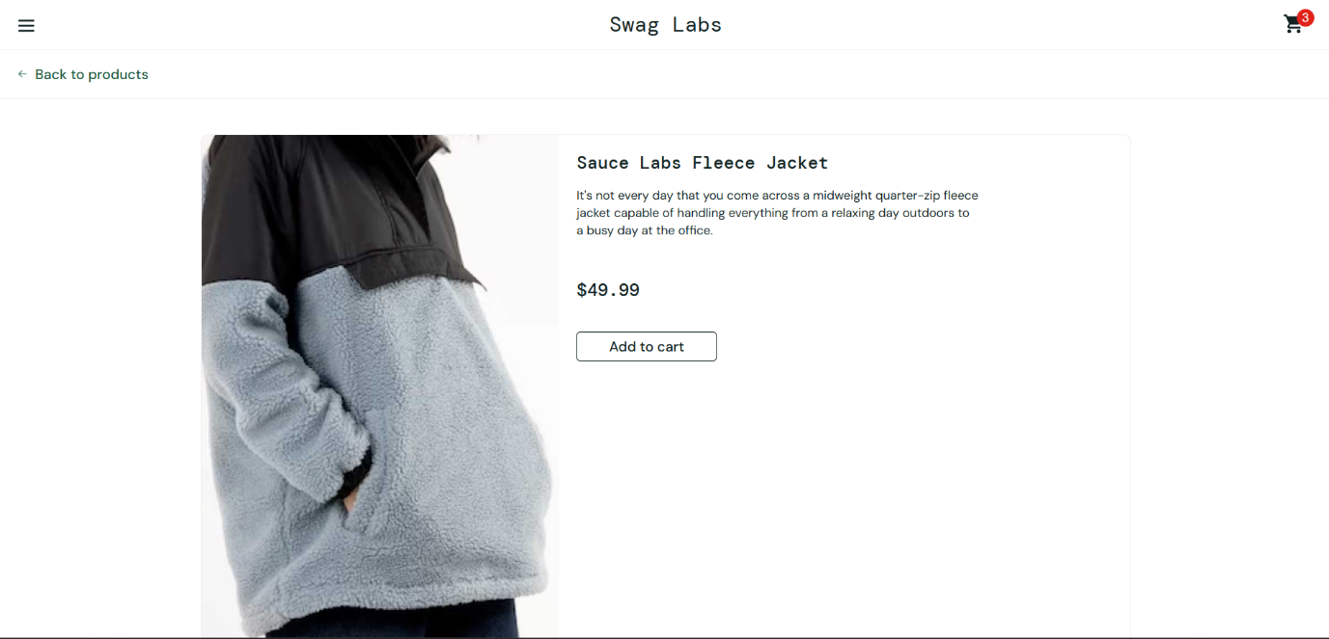

**Root Cause Analysis (Initial Assessment)**

* Incorrect product URL mapping in navigation links
* Product routing configuration error
* Wrong product ID assigned to backpack navigation link
* Possible hardcoded redirect for problem_user account

**Impact Assessment**

* **User Impact**: Medium - Users cannot access intended product details
* **Business Impact**: Medium - Potential loss of sales for backpack product
* **Frequency**: Appears to be specific to problem_user account

**Test Cases to Verify Fix**

1. Login as problem_user and click "Sauce Labs Backpack" - verify correct redirection
2. Test all product navigation links for correct redirections
3. Test with other user accounts to ensure issue is isolated
4. Verify backpack product page is accessible through direct URL

**Status**: Open **Assigned To**: [Frontend Development Team] **Next Action**: Investigate product navigation routing and URL mapping

**Bug Report 3: Cart Functionality Limitation**

**Bug ID:** BUG-003 **Date Reported:** June 25, 2025 **Reporter:** DUMNE VIJAY

**Environment**

* **Application**: https://www.saucedemo.com/
* **Version**: V1
* **Browser**: Chrome Version 137.0.7151.120 (Official Build) (64-bit)
* **OS**: Windows 11
* **Test Environment**: Prod

**Bug Summary** Users can only add 3 items to cart despite 6 items being available, and cannot remove items from cart on homepage.

**Severity: High** - Core e-commerce functionality is restricted **Priority: P1** - Critical for business operations **Bug Type:** Functional Defect

**Steps to Reproduce**

1. Login as problem_user
2. Navigate to products page
3. Try to add more than 3 items to cart
4. Attempt to remove items from cart on homepage
5. Observe cart behavior

**Expected Result**

* Users should be able to add all available items to cart (6 items)
* Users should be able to remove items from cart on any page
* Cart functionality should work consistently

**Actual Result**

* Cart stops accepting items after 3 additions
* Remove functionality is not working on homepage
* Cart has artificial limitation not documented

**Additional Information** **Test Data Used**

* **Username**: problem_user
* **Password**: secret_sauce
* **Available Items**: 6 products total

**Screenshots**

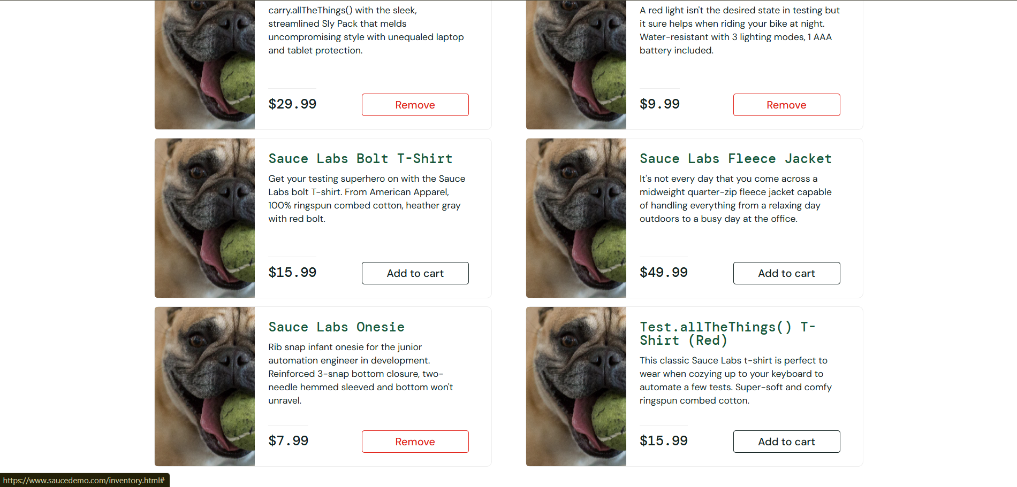

**Root Cause Analysis (Initial Assessment)**

* Cart limit hardcoded for problem_user account
* Remove functionality not properly implemented on homepage
* Possible JavaScript error preventing cart updates

**Impact Assessment**

* **User Impact**: High - Cannot complete desired purchases
* **Business Impact**: High - Direct revenue impact, customers cannot buy multiple items
* **Frequency**: Specific to problem_user, needs testing with other accounts

**Test Cases to Verify Fix [TC_002]**

1. Verify ability to add all 6 items to cart
2. Test remove functionality on all pages
3. Verify cart persistence across page navigation
4. Test with different user accounts

**Status**: Open **Assigned To**: [E-commerce Development Team] **Next Action**: Investigate cart limitations and remove functionality

**Bug Report 4: Checkout Form Input Field Error**

**Bug ID:** BUG-004 **Date Reported:** June 25, 2025 **Reporter:** DUMNE VIJAY

**Environment**

* **Application**: https://www.saucedemo.com/
* **Version**: V1
* **Browser**: Chrome Version 137.0.7151.120 (Official Build) (64-bit)
* **OS**: Windows 11
* **Test Environment**: Prod

**Bug Summary** On checkout page, when entering First Name and Last Name, the Last Name text appears to append to First Name field instead of staying in separate fields.

**Severity: High** - Critical checkout process failure **Priority: P1** - Blocks order completion **Bug Type:** UI/Functional Defect

**Steps to Reproduce**

1. Login as problem_user
2. Add items to cart
3. Navigate to checkout page
4. Enter text in "First Name" field
5. Enter text in "Last Name" field
6. Observe field behavior

**Expected Result**

* First Name and Last Name should remain in separate fields
* Each field should maintain its own input value
* Form should accept input correctly for checkout process

**Actual Result**

* Last Name text appears to append to First Name field
* Form fields are not functioning independently
* Checkout process cannot be completed properly

**Additional Information** **Test Data Used**

* **Username**: problem_user
* **Test Data**: Any first name and last name input

**Screenshots**

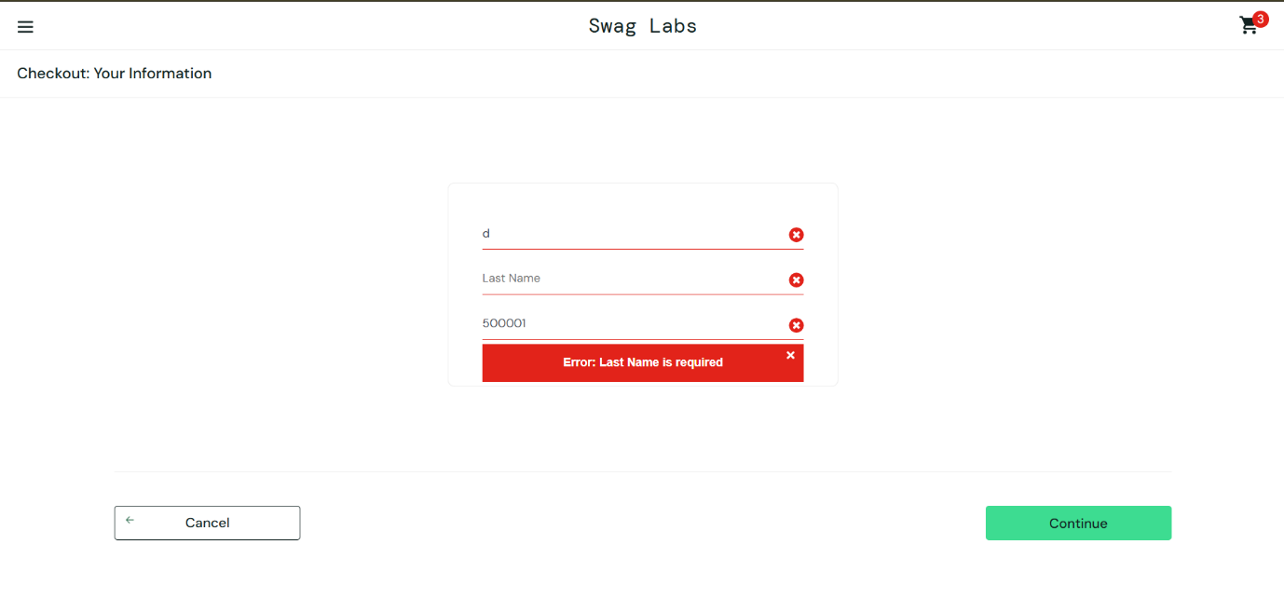

**Root Cause Analysis (Initial Assessment)**

* JavaScript form handling error
* Incorrect field ID or name mapping
* Event listener attached to wrong form elements
* Possible CSS styling affecting field behavior

**Impact Assessment**

* **User Impact**: High - Cannot complete checkout process
* **Business Impact**: Critical - Blocks all sales completion
* **Frequency**: Affects checkout process, needs immediate attention

**Test Cases to Verify Fix**

1. Verify First Name and Last Name fields work independently
2. Test form submission with proper field values
3. Verify checkout process completion
4. Test with different browsers and user accounts

**Status**: Open **Assigned To**: [Frontend/Checkout Team] **Next Action**: Immediate investigation of form field JavaScript and HTML structure

**Bug Report 5: Item Sorting Failure on Products Page**  
**Bug ID:** BUG-005  
**Date Reported:** June 25, 2025  
**Reporter:** DUMNE VIJAY

**Environment**

* **Application:** <https://www.saucedemo.com/>
* **Version:** V1
* **Browser:** Chrome Version 137.0.7151.120 (Official Build) (64-bit)
* **OS:** Windows 11
* **Test Environment:** Prod

**Bug Summary**

When logged in as error_user, attempting to use the sorting dropdown (e.g., "Name (A to Z)") results in a popup error message indicating the sorting functionality is broken. No sorting is applied, and the user is forced to acknowledge the alert before proceeding.

**Severity:**

Medium – Non-blocking, but critical for usability and experience

**Priority:**

P2 – Should be fixed in the next release

**Bug Type:**

Functional/UI Defect

**Steps to Reproduce**

1. Navigate to the login page
2. Login with username: error_user, password: secret_sauce
3. On the products page, click the sorting dropdown
4. Select any sorting option (e.g., Name A-Z)
5. Observe the system response

**Expected Result**

* Products should be sorted according to the selected option
* No alert or error messages should be shown

**Actual Result**

* Popup displays message:  
  "Sorting is broken! This error has been reported to Backtrace."
* Sorting does not take effect
* User experience is interrupted by alert

**Additional Information**

**Test Data Used**

* Username: error_user
* Password: secret_sauce

**Screenshot:**  
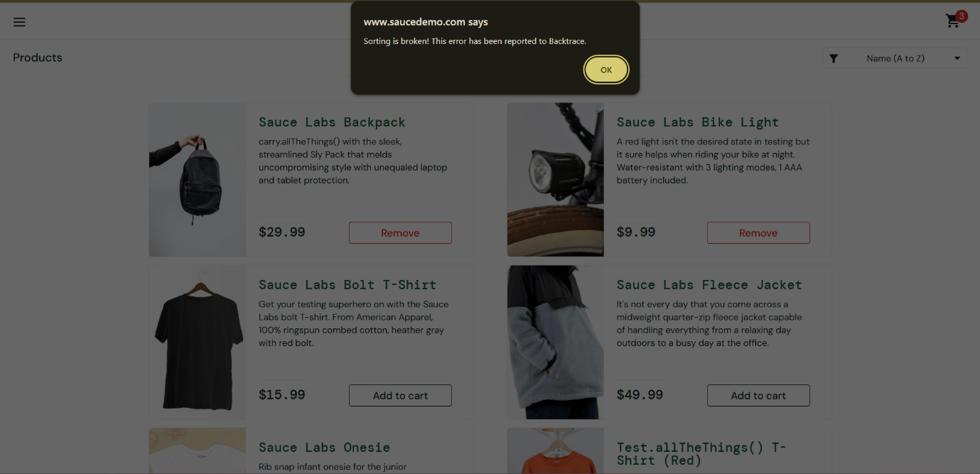

**Root Cause Analysis (Initial Assessment)**

* Sorting logic may not be implemented for this user type
* Backend/JS event handling may throw uncaught exceptions
* Error appears intentional/test-induced for this specific user account

**Impact Assessment**

* **User Impact:** Medium – User cannot sort items
* **Business Impact:** Medium – Potential UX issue for demo or QA users
* **Frequency:** Specific to error_user

**Suggested Fix Priority**

Fix required to maintain sorting functionality across all user types

**Test Cases to Verify Fix**

1. Login as error_user, test all sorting options
2. Compare results with standard_user for consistency
3. Ensure no popup appears during sorting
4. Verify correct order and content after sort

**Bug Report 6: Checkout Form Last Name Field Disabled for error_user**  
**Bug ID:** BUG-006  
**Date Reported:** June 25, 2025  
**Reporter:** DUMNE VIJAY

**Environment**

* **Application:** <https://www.saucedemo.com/>
* **Version:** V1
* **Browser:** Chrome Version 137.0.7151.120 (Official Build) (64-bit)
* **OS:** Windows 11
* **Test Environment:** Prod

**Bug Summary**

While checking out as error_user, the "Last Name" field on the checkout form is unresponsive and does not accept input. The user is unable to proceed due to incomplete form data.

**Severity:**

High – Prevents order completion

**Priority:**

P1 – Immediate fix required

**Bug Type:**

Functional/UI Defect

**Steps to Reproduce**

1. Login as error_user, password: secret_sauce
2. Add any items to the cart (limited to 3)
3. Proceed to checkout
4. Try entering "First Name" and "Last Name"
5. Observe inability to type into the Last Name field

**Expected Result**

* User should be able to input both First and Last Name
* Form should validate and allow continuing to next step

**Actual Result**

* First Name accepts input
* Last Name field is disabled or unresponsive
* User is blocked from proceeding

**Additional Information**

**Test Data Used**

* Username: error_user
* Password: secret_sauce

**Screenshot:**  
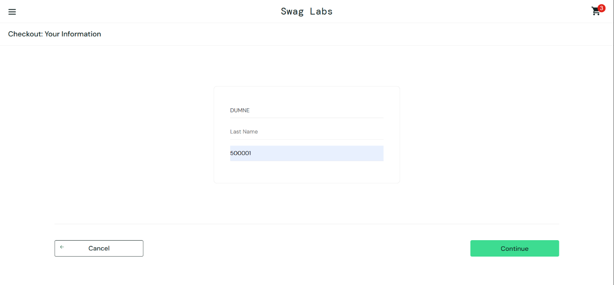

**Root Cause Analysis (Initial Assessment)**

* Input field may be disabled via JavaScript or HTML attribute
* Event listener for Last Name input may not be bound
* Intentional bug scenario for error_user profile

**Impact Assessment**

* **User Impact:** High – Cannot complete order
* **Business Impact:** High – Checkout flow broken
* **Frequency:** Specific to error_user

**Test Cases to Verify Fix**

1. Verify both input fields accept text
2. Ensure form can be submitted with valid data
3. Validate against form errors and required fields
4. Test across all user types

**Bug Report 7: Incorrect Product Image Displayed for visual_user**

**Bug ID:** BUG-007  
**Date Reported:** June 25, 2025  
**Reporter:** DUMNE VIJAY

**Environment**

* **Application:** <https://www.saucedemo.com/>
* **Version:** V1
* **Browser:** Chrome Version 137.0.7151.120 (Official Build) (64-bit)
* **OS:** Windows 11
* **Test Environment:** Prod

**Bug Summary**

When logged in as visual_user, the first product image is replaced with a picture of a dog instead of the expected product image (Sauce Labs Backpack). This misrepresents the product and impacts user trust.

* **Severity:** High – Critical visual discrepancy affecting user perception
* **Priority:** P1 – Should be fixed immediately to maintain visual integrity
* **Bug Type:** UI/Visual Defect

**Steps to Reproduce**

1. Navigate to the login page
2. Login using username: visual_user and password: secret_sauce
3. Observe the image displayed for the first item (Sauce Labs Backpack)

**Expected Result**

* The product image should match the item (Sauce Labs Backpack)
* No irrelevant or incorrect images should be displayed

**Actual Result**

* A dog image is shown instead of the backpack product
* Product name and price are correct, but image is unrelated

**Additional Information**

**Test Data Used:**

* Username: visual_user
* Password: secret_sauce

**Screenshots:**

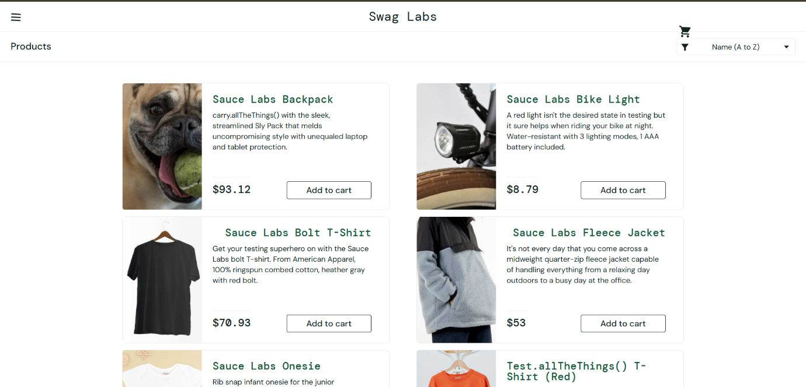

**Root Cause Analysis (Initial Assessment)**

* Image mapping likely broken or replaced intentionally
* User-specific test condition may be active
* Asset mismatch or JavaScript selector error

**Impact Assessment**

* **User Impact:** High – Confusing for end user, may question site reliability
* **Business Impact:** Medium – Impacts product visibility and sales
* **Frequency:** Specific to visual_user account

**Suggested Fix Priority**

* Fix immediately to restore brand and visual accuracy

**Test Cases to Verify Fix**

1. Login as visual_user and verify correct image for each product
2. Compare product image consistency with standard_user
3. Validate image source URLs and asset loading

**Status: Open**

**Assigned To:** [Frontend QA or Asset Management Team]  
**Next Action:** Investigate user-specific image mapping logic

**Bug Report 8: Cart Icon Misalignment for visual_user**

**Bug ID:** BUG-008  
**Date Reported:** June 25, 2025  
**Reporter:** DUMNE VIJAY

**Environment**

* **Application:** <https://www.saucedemo.com/>
* **Version:** V1
* **Browser:** Chrome Version 137.0.7151.120 (Official Build) (64-bit)
* **OS:** Windows 11
* **Test Environment:** Prod

**Bug Summary**

For the user visual_user, the cart icon on the top navigation bar appears misaligned—pushed down from its usual position—affecting UI consistency.

* **Severity:** Medium – Visual issue that may confuse users
* **Priority:** P2 – Should be corrected in UI update cycle
* **Bug Type:** UI/Visual Defect

**Steps to Reproduce**

1. Login to the application using visual_user
2. Observe the top-right section of the navigation bar
3. Focus on the cart icon placement

**Expected Result**

* Cart icon should be vertically centered and aligned
* UI should match layout shown for standard_user

**Actual Result**

* Cart icon appears lower than expected
* Other UI elements are aligned, indicating isolated issue

**Additional Information**

**Test Data Used:**

* Username: visual_user
* Password: secret_sauce

**Screenshots:**

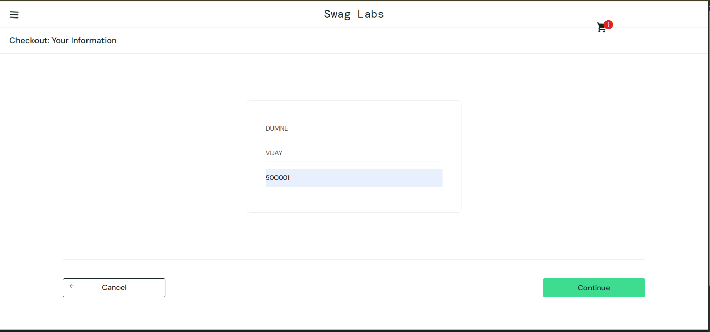

**Root Cause Analysis (Initial Assessment)**

* Custom CSS applied for visual_user
* Margin or padding issue in scoped stylesheet
* Rendering quirk introduced by feature flagging

**Impact Assessment**

* **User Impact:** Medium – Inconsistent experience
* **Business Impact:** Low – No direct feature impact
* **Frequency:** Specific to visual_user

**Suggested Fix Priority**

* Include in next UI patch release

**Test Cases to Verify Fix**

1. Validate icon position for all users
2. Inspect CSS affecting cart icon
3. Confirm fix across screen resolutions

**Status: Open**

**Assigned To:** [Frontend Development Team]  
**Next Action:** Audit CSS overrides for visual_user

**Bug Report 9: Misaligned “Continue Shopping” Button on Cart Page**

**Bug ID:** BUG-009  
**Date Reported:** June 25, 2025  
**Reporter:** DUMNE VIJAY

**Environment**

* **Application:** <https://www.saucedemo.com/>
* **Version:** V1
* **Browser:** Chrome Version 137.0.7151.120 (Official Build) (64-bit)
* **OS:** Windows 11
* **Test Environment:** Prod

**Bug Summary**

On the Cart page while logged in as visual_user, the “Continue Shopping” button is misaligned or offset, disrupting layout balance.

* **Severity:** Low – Aesthetic UI issue
* **Priority:** P3 – Fix during minor release
* **Bug Type:** UI Layout Defect

**Steps to Reproduce**

1. Login using visual_user credentials
2. Add a product to the cart
3. Click the cart icon
4. Check the placement of the “Continue Shopping” button

**Expected Result**

* Button should be centered or evenly aligned with other elements

**Actual Result**

* Button appears shifted or not centered
* Slight visual imbalance on the page

**Additional Information**

**Test Data Used:**

* Username: visual_user
* Password: secret_sauce

**Screenshots:**

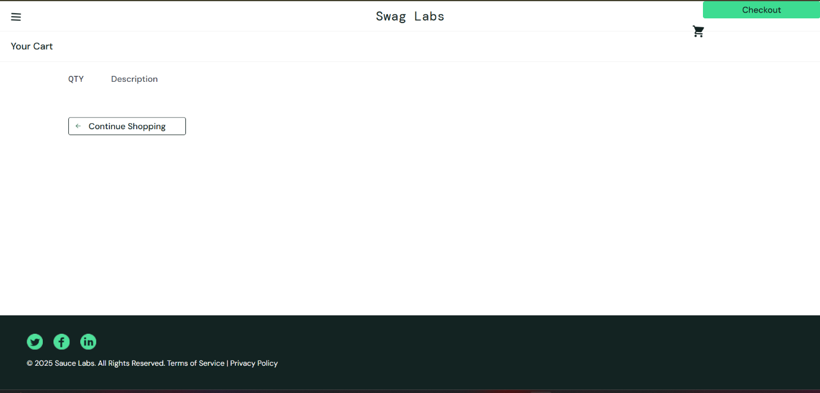

**Root Cause Analysis (Initial Assessment)**

* Container alignment issue in cart layout
* CSS class override or missing grid/flexbox rule
* User-specific display modification

**Impact Assessment**

* **User Impact:** Low – Minor inconvenience
* **Business Impact:** Low – Cosmetic, non-functional
* **Frequency:** Reproducible for visual_user only

**Suggested Fix Priority**

* Include with minor UI/UX refinements

**Test Cases to Verify Fix**

1. Check alignment across all user types
2. Inspect layout rules in cart page template
3. Verify responsive behavior on various resolutions

**Status: Open**

**Assigned To:** [Frontend UI Team]  
**Next Action:** Correct alignment and verify across accounts

**Bug Report 10: Sluggish Performance and Delays for performance_glitch_user**

**Bug ID:** BUG-010  
**Date Reported:** June 25, 2025  
**Reporter:** DUMNE VIJAY

**Environment**

* **Application:** <https://www.saucedemo.com/>
* **Version:** V1
* **Browser:** Chrome Version 137.0.7151.120 (Official Build) (64-bit)
* **OS:** Windows 11
* **Test Environment:** Prod

**Bug Summary**

When logged in as performance_glitch_user, the application exhibits significant delays across multiple actions including login, sorting items on the products page, and navigating back to the home page after completing a checkout. The performance lag affects the overall user experience.

* **Severity:** High – System responsiveness and usability impacted
* **Priority:** P1 – Requires performance optimization
* **Bug Type:** Performance Defect

**Steps to Reproduce**

1. Navigate to the login page
2. Login using username: performance_glitch_user and password: secret_sauce
3. Observe the delay during login
4. On the products page, attempt to sort items by any option (e.g., "Price (low to high)")
5. Add items to the cart and complete the checkout process
6. Click the “Back Home” button after order completion
7. Observe performance during each action

**Expected Result**

* Login, sorting, and navigation actions should respond within normal expected time (under 1-2 seconds)
* UI should not freeze or hang during actions
* “Back Home” button should redirect promptly to homepage

**Actual Result**

* Login takes more than 6–8 seconds to load product page
* Sorting operation results in lag or temporary freeze before updating product order
* Clicking “Back Home” after checkout causes extended delay before redirection
* Intermittent loading spinners or blank screens are observed

**Additional Information**

**Test Data Used:**

* Username: performance_glitch_user
* Password: secret_sauce

**Screenshots:**

* N/A (Performance issue – captured via observation)

**Root Cause Analysis (Initial Assessment)**

* Backend performance throttled or deliberately slowed for this user account
* Possible test case for evaluating application responsiveness under slow conditions
* JavaScript event loop may be blocked by heavy synchronous operations
* Sorting may be triggering inefficient DOM or data re-renders

**Impact Assessment**

* **User Impact:** High – Frustrating user experience and navigation flow
* **Business Impact:** Medium – May affect customer retention and trust
* **Frequency:** Specific to performance_glitch_user

**Suggested Fix Priority**

* High – Optimize application performance and remove artificial bottlenecks

**Test Cases to Verify Fix**

1. Login as performance_glitch_user and measure load time
2. Perform sorting actions and validate sorting completes within expected time
3. Complete checkout and click “Back Home” – confirm response time is reduced
4. Compare performance across all user types

**Status: Open**

**Assigned To:** [Performance Optimization Team / Backend Team]  
**Next Action:** Profile performance metrics and resolve bottlenecks for performance_glitch_user

**Bug Report 11: Cart State Not Reset Properly After Reset App State Action**

**Bug ID:** BUG-011  
**Date Reported:** June 25, 2025  
**Reporter:** DUMNE VIJAY

**Environment**

* **Application:** <https://www.saucedemo.com/>
* **Version:** V1
* **Browser:** Chrome Version 137.0.7151.120 (Official Build) (64-bit)
* **OS:** Windows 11
* **Test Environment:** Prod

**Bug Summary**

When logged in as standard_user, after adding all items to the cart and clicking the "Reset App State" option, the cart is cleared internally, but the UI still displays **"Remove"** instead of **"Add to cart"** for the items. The UI only updates correctly when another action (e.g., clicking a product or sorting) is performed.

* **Severity:** Medium – Functional/UI inconsistency
* **Priority:** P2 – Should be addressed in the next release
* **Bug Type:** UI/Functional Defect

**Steps to Reproduce**

1. Login with username: standard_user, password: secret_sauce
2. Add all items to the cart
3. Click the menu (☰) and choose **"Reset App State"**
4. Observe the product buttons still showing **"Remove"** instead of **"Add to cart"**
5. Perform another action (e.g., sort items or click on a product)
6. Observe that button texts change correctly to **"Add to cart"**

**Expected Result**

* Clicking **"Reset App State"** should clear the cart and immediately update the product buttons to **"Add to cart"**
* UI should reflect the reset state instantly without requiring further user actions

**Actual Result**

* UI still shows **"Remove"** on product buttons even after resetting the app state
* Cart is technically empty, but UI doesn't reflect the reset until another user interaction occurs

**Additional Information**

**Test Data Used:**

* Username: standard_user
* Password: secret_sauce

**Screenshots:**

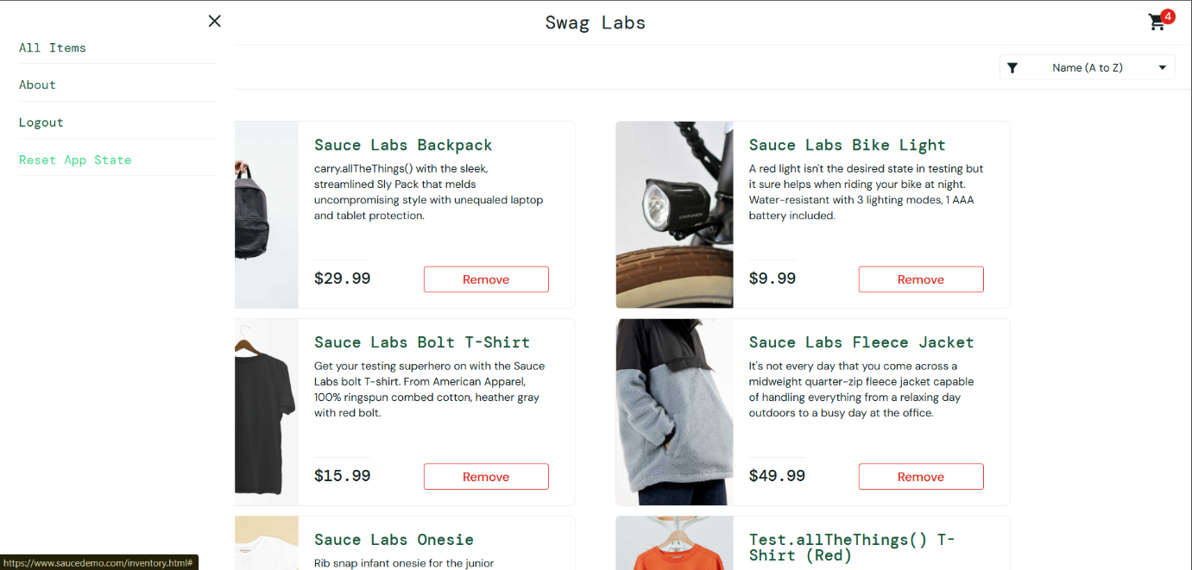

**Root Cause Analysis (Initial Assessment)**

* UI state not refreshed after internal cart state is cleared
* Possibly missing re-render trigger or DOM update on Reset App State
* Reset logic might be updating store/state but not triggering UI reactivity

**Impact Assessment**

* **User Impact:** Medium – Causes confusion, perceived inconsistency in cart state
* **Business Impact:** Low – Doesn’t block purchases but affects user trust
* **Frequency:** Consistent – Happens every time this sequence is followed

**Suggested Fix Priority**

* Medium – Should be fixed to align UI with backend/cart state instantly

**Test Cases to Verify Fix**

1. Login as standard_user and add items to cart
2. Reset app state and verify product buttons instantly show **"Add to cart"**
3. Test without performing any other actions post-reset
4. Validate UI-cart consistency across other user types

**Status: Open**

**Assigned To:** [Frontend Team / UI State Management Team]  
**Next Action:** Ensure UI refreshes immediately after reset; validate React/Vue state handling (if applicable)

**Bug Report 12: UI Layout Spacing Issue on Mobile View**

**Bug ID:** BUG-012  
**Date Reported:** June 25, 2025  
**Reporter:** DUMNE VIJAY

**Environment**

* **Application:** <https://www.saucedemo.com/>
* **Version:** V1
* **Browser:** Chrome Version 137.0.7151.120 (Official Build) (64-bit)
* **OS:** Windows 11
* **Test Environment:** Prod

**Bug Summary**

When logged in as standard_user, viewing the product listing page in **mobile screen resolution** reveals excessive white space between the item name/description and its corresponding price. This creates poor alignment and an inconsistent user interface, impacting usability and aesthetic.

* **Severity:** Low – Cosmetic/UI issue
* **Priority:** P3 – Fix in future UI enhancement cycle
* **Bug Type:** UI Layout Defect

**Steps to Reproduce**

1. Login with username: standard_user, password: secret_sauce
2. Open **Chrome Developer Tools**
3. Toggle device toolbar (Ctrl+Shift+M)
4. Select a mobile device (e.g., iPhone SE, Pixel 5, etc.) from the responsive options
5. Observe the layout of item text (product name and description) and the item price
6. Notice large blank white space between them

**Expected Result**

* Product name/description and price should be closely aligned
* Layout should adjust properly in mobile view with balanced padding and spacing
* Mobile responsiveness should retain visual consistency

**Actual Result**

* Excessive white space is seen between product name and price
* Layout appears broken or misaligned on smaller screens
* Affects readability and user experience

**Additional Information**

**Test Data Used:**

* Username: standard_user
* Password: secret_sauce

**Testing Note:**

* Issue appears only in mobile or narrow screen sizes
* Make sure to select **mobile device view** in Chrome DevTools for testing

**Screenshot:**  
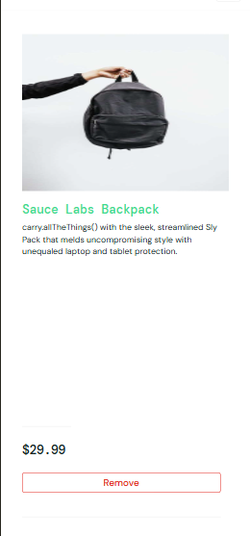

**Root Cause Analysis (Initial Assessment)**

* Improper CSS flexbox/grid layout behavior on smaller screen widths
* Missing or ineffective responsive design breakpoints
* Fixed width or padding applied to product text or price container

**Impact Assessment**

* **User Impact:** Low – Visual UI flaw, does not affect core functionality
* **Business Impact:** Low – Impacts mobile user experience and visual quality
* **Frequency:** Consistent in mobile screen view

**Suggested Fix Priority**

Low – Schedule with next UI/UX improvement sprint

**Test Cases to Verify Fix**

1. Login as standard_user, view site in mobile screen
2. Verify that product name and price are correctly aligned
3. Check across multiple mobile screen resolutions
4. Ensure visual consistency and responsiveness

**Status: Open**

**Assigned To:** [UI/Frontend Development Team]  
**Next Action:** Update responsive CSS rules and adjust mobile layout spacing

**Summary**

This report documents twelve active bugs identified in the SauceDemo application across different user profiles, browser versions, and UI states. Key issues include **authentication failures**, **navigation misrouting**, **cart limitations**, **checkout form malfunctions**, **product misrepresentation**, **UI misalignments**, and **performance degradation**. These defects range in severity from minor UI layout inconsistencies to critical functional blocks preventing login and order completion. Priority levels span P1 to P3 depending on impact. Root causes point to a mix of **user-specific behavior scripts**, **JavaScript/HTML errors**, **state management flaws**, and **incomplete responsive design implementation**. Immediate attention is required for critical bugs to restore essential application functionality, especially for locked-out users, broken cart flows, and checkout blockers.